About Harlem, a famous___________in NYC

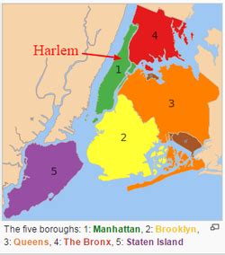 | To answer the questions about Harlem read your  Lesson and go to  https://kids.kiddle.co/Harlem#History  1-Where exactly is it located ?  2-It is divided into smaller areas, can you name some of them ?  3-What is it named after ? why ?  4-What has it been known as since the 1920s ?

About Harlem, a famous___________in NYC

To answer the questions about Harlem read your
Lesson and go to
https://kids.kiddle.co/Harlem#History

1-Where exactly is it located ?

2-It is divided into smaller areas, can you name some of them ?

3-What is it named after ? why ?

4-What has it been known as since the 1920s ?

